## **Problem Statement:**

What opportunities exist for Big Mountain Resort to effectively develop and implement a new pricing strategy that can maximize capitalization in their facilities investments to offset their recent additional operating cost by $1,540,000 this season.

## **Project Context:**

Big Mountain Resort overlooks Glacier National Park and Flathead National Forest. With access to an abundant 105 runs and attracting 350,000 skiers and snowboarders each year, there is a desire to better capitalize on the opportunity for a better value per ticket price for their customers. Under consideration are a reduction in operating costs without sacrificing the great quality provided or ticket price, or a justification for an increase in ticket price

## **Current Strategy:**

Currently Big Mountain Resort employs a non-dynamic market average for their ticket price, which is unsustainable with recent increased operating costs and will lose out on an edge over the competition.

## **Proposed Modeling Scenarios:**

Big Mountain Resort has given several options for either reducing operating costs or increasing ticket prices. Ticket price is independent of other variables as Big Mountain is able to set whichever price they wish. However the present market shows people paying more for some facilities and less for others. Our model will explore these facilities to determine a best price model

Some listed options:

* Permanently closing down up to 10 of the least used runs
* Increasing vertical drop by adding in a run to 150 ft further down. This will necessitate another lift and run being input as well as additional snow coverage
* The above but with an increase in 2 acres of snow making
* Increasing the longest run to 3.5 miles which would add 4 acres of snow making

The expected number of visitors for the season is 350,000 with an average of 5 days of skiing. The additional lift is assumed to be included in the data

## **Feature Correlations:**

* Correlation Heatmap- A great way to see a high level view and patterns between the correlation of features is with a heatmap. From the below map we can see the following:
  + Summit and base elevation are highly correlated but this is expected
  + For AdultWeekend there is a high correlation with fastQuads, Runs, and Snow Making_ac
  + From the Snow Making correlation it seems customers look highly upon guaranteed snow which could mean increased cost and price for more equipment
  + Runs and total chairs being well correlated with price also makes sense as with more runs, more chairs to ferry to the runs would be needed. However we do see that total skiable area is not as important as snow making area

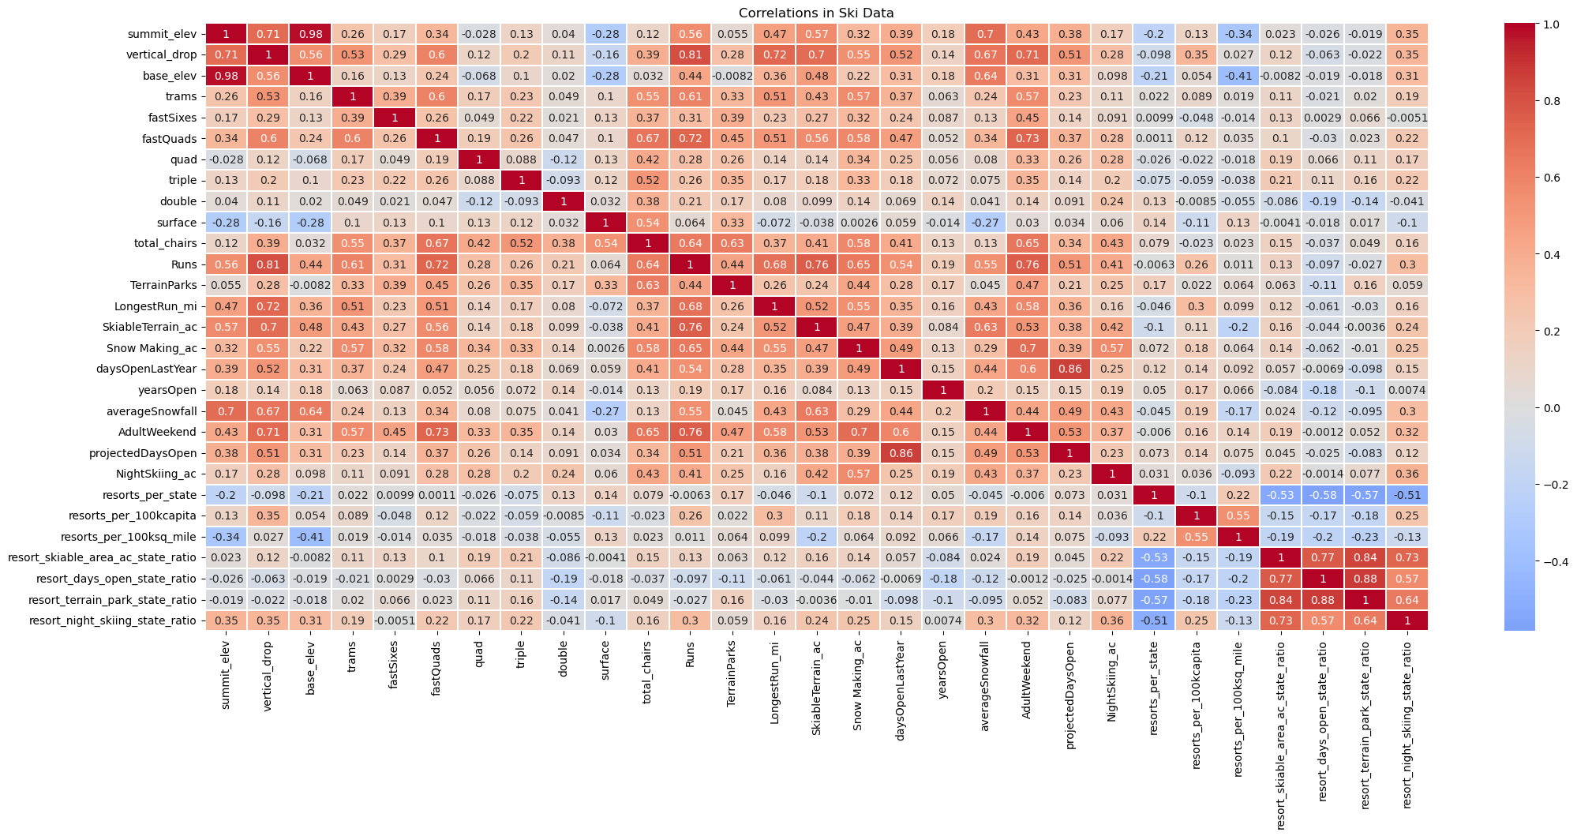

* Correlation scatterplots- Heatmaps are good for a high level view, however scatterplots can show more detail in 2 variables
  + From the scatterplots we can see vertical drop is a strong positive correlation
  + fastQuads, Runs, and total chairs also are quite useful

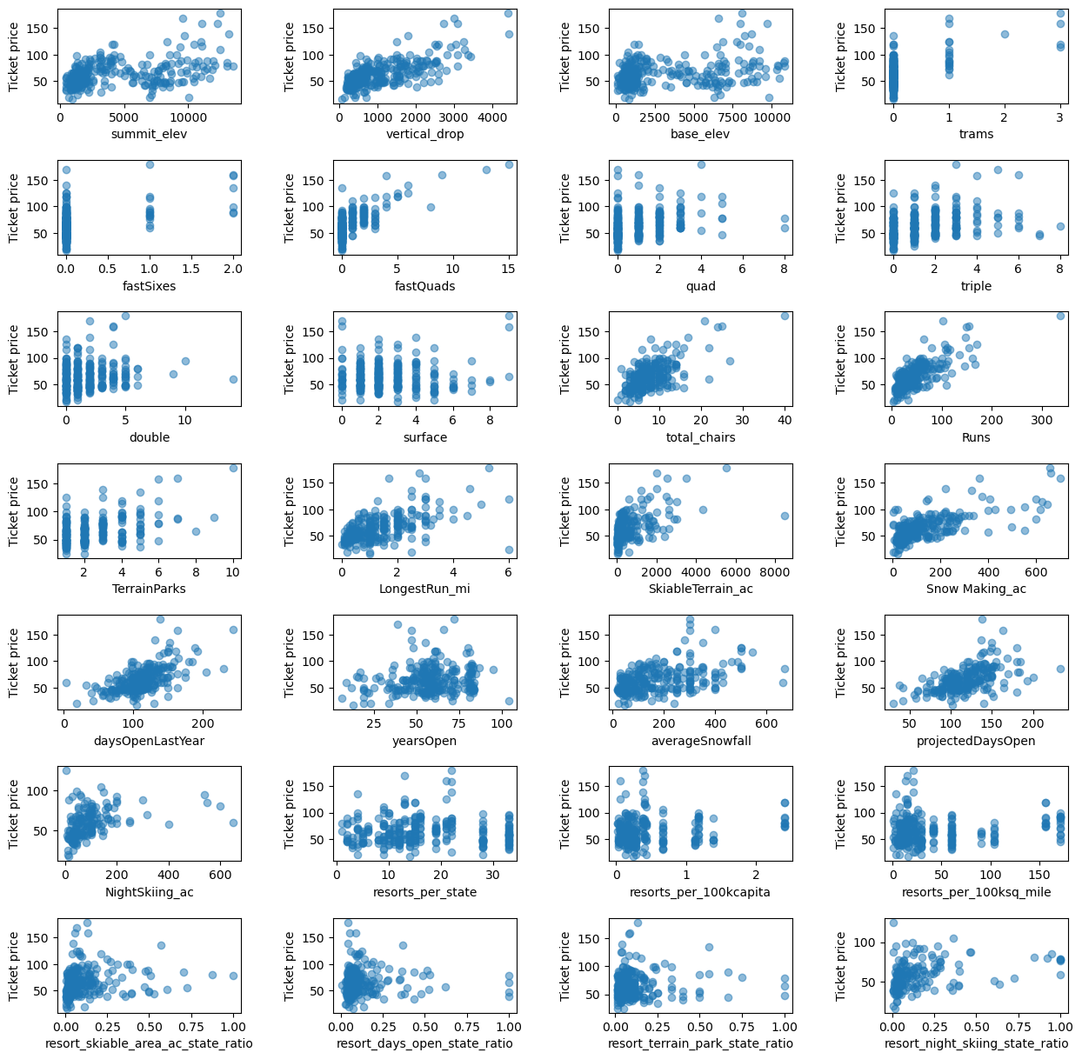

## **Pre-Processing and Training Data:**

* **Linear Model**: Missing values were also kept with the mean and median values and using this model, we were off by about $9. However we did need to adjust the number of features by cross-validating the data. A value of k=8 was used to focus on vertical_dropo, Snow Making_ac, total_chairs, fastQuads, Runs, LongestRun_mi, trams, and SkiableTerrain_ac which fit our initial assumptions from our summary in Exploratory Data Analysis
* **Random Forest Model**: This model was also developed including the missing values as in the linear model. The random forest model revealed that the top four features are fastQuads, Runs, Snow Making_ac, and vertical drop which again fits our assumptions from Exploratory Data Analysis
* Because of this, the **Random Forest Model** was chosen

## **Recommendations:**

* Our model suggests that the current ticket price is 16% lower than the price derived from the model scenarios. There are potential scenarios for either cutting costs by closing runs or increasing ticket price by adding more vertical drop, adding snow making, or increasing the longest run
* Increasing the vertical drop by 150 ft would increase ticket price support from $81 to $89.46 which would increase revenue by $15,065,471
* Adding 2 acres of snow making would increase the price support to $90.75 increasing revenue by $17,068,841.
* Closing up to 10 runs:
  + Closing 1 run would have no impact on Ticket price or revenue
  + Closing 2 runs would reduce ticket price by $0.40 and revenue by $750,000
  + Closing 3-5 runs would reduce ticket price by $0.67 and revenue by $1,25M
  + Closing up to 10 runs would reduce ticket price and thus revenue by $3M

## **Conclusion:**

After applying our prediction models the following was found to be the best scenario:

* By adding in 150ft of vertical drop, 1 chair lift, 1 run, and 2 acres of snow making cover
* This scenario increased ticket price support to $90.75 with a net revenue of $15,528,841 after the $1.45M operating costs
* Because we lack the operating costs per run and weekday pricing, we cannot recommend shutting down runs or implementing a dynamic pricing model

